|  |
| --- |
| http://upload.wikimedia.org/wikipedia/commons/thumb/1/13/First_permanent-waving_heaters_designed_by_Calvete_in_1917.jpg/200px-First_permanent-waving_heaters_designed_by_Calvete_in_1917.jpg |
| First permanent-waving heaters designed by Calvete in 1917 |

Historically, women have wished to have wavy or curly hair which seemed more attractive than the common straight hair. Attempts to curl it by wetting and winding or tying with paper produces only superficial effects. Washing would immediately destroy the waving. High temperatures were known to be effective for waving but impractical unless applied to hair separated from the scalp, which is how wigs were made. An early system consisted of a system of winding and holding the hair on a former which was then inserted each time into the electric heater.

A wireless permanent-waving machine introduced in 1934 by Icall Limited to satisfy a demand for a machine in which there was no direct connection to electricity when the heaters were applied. Because such heaters started cooling as soon as they were applied to the hair, they were bulkier so as to provide a greater heat sink. Even so, timing had to be longer because of the cooling of the heater and waves tended to be softer.

|  |
| --- |
| http://upload.wikimedia.org/wikipedia/commons/thumb/c/c6/Icall_1934_Wireless_Permanent_Waving_Machine.jpg/260px-Icall_1934_Wireless_Permanent_Waving_Machine.jpg |
| A Wireless Permanent-Waving Machine designed by Icall in 1934, in which the heaters were disconnected before applying to the head, known as the "falling-heat" method. The heaters were bulkier so as to store more heat, since they began to cool as soon as applied. The heat was controlled according to the type of hair by a thermostat control. |

Icall also pioneered the use of plastics in hairdressing equipment, specifically a thermosetting plastic, Bakelie which was used not only because of its electrical properties in the windings of motors and heaters, but also in the outer coverings of the heaters. They were less affected by corrosion and were less likely to burn the fingers of the hairdresser. Icall also use Bakelite for the outer casings of hand-held hair-dryers and also for the large linings of pedestal hair-dryers.

It can be imagined that at time when electrical installations were not to today’s standards and at one time were not even earthed, the application of electrical windings to wet hair resulted in enough accidents to worry women. Icall developed what was called the ‘wireless’ system, in which the electric lead to the heater was replaced by a cord which took the weight of the heater, and the heater was heated by plugging into a socket in the chandelier. Outwardly the machine looked similar to the earlier model, but at no times was there an electric potential near the head.

Questions

1. Describe what is meant by a “heat sink” for the bulkier heaters that were attached to the hair. (2)
2. The first synthetic plastic Bakelite was uses extensively for heating and electrical applications. Explain a property of Bakelite that would have:
   1. Kept hairdressers from burning their fingers. (2)
   2. Prevented the hairdresser rom getting a shock when disconnecting the heaters. (2)
3. Describe the danger to women having their wet hair curled that the wireless system was addressing. (3)
4. There are 16 hair rolling formers and heaters attached in the chandelier for heating.  
   Would you expect the formers to be connected in series or in parallel? Justify your answer. (3)
5. Draw a circuit diagram showing how three (3) of the formers would be connected to the power supply below. Include a switch and fuse in your circuit to protect your formers. (2)

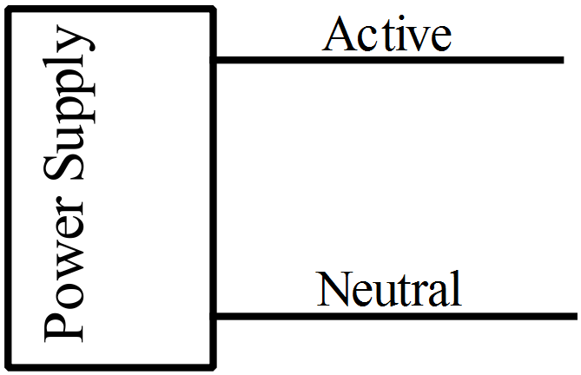

1. Each of the 16 former and heater combinations were made of brass with a mass of 235 grams with equal resistances. If an Australian version took 6·50 minutes to heat all the formers to a working temperature of 88·7 °C from 23·5 °C, what was the resistance in the circuit? (6)